**Assignment-6 (Python)**

**1. Write a Python program to read a file line by line and store it into a list.**

Sol.

def file_read(fname):

with open(fname) as f:

content_list = f.readlines()

print(content_list)

file_read('test.txt')

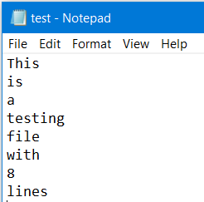

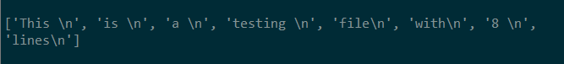

**2. Write a Python program to read a file line by line store it into an array.**

Sol.

def file_read(fname):

content_array = []

with open(fname) as f:

for line in f:

content_array.append(line)

print(content_array)

print(type(content_array))

file_read('test.txt')





**3. Write a Python program to read a random line from a file.**

Sol.

import random

def random_line(fname):

lines = open(fname).read().splitlines()

return random.choice(lines)

print(random_line('test.txt'))





**4. Write a Python program to combine each line from first file with the corresponding line in second file**

Sol.

print('\n')

with open('test.txt') as fh1, open('test2.txt') as fh2:

for line1, line2 in zip(fh1, fh2):

print(line1+line2)

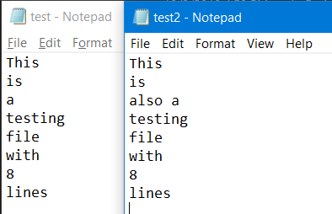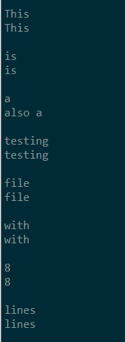

**5. Write a Python program to generate 26 text files named A.txt, B.txt, and so on up to Z.txt.**

Sol.

import string

for letter in string.ascii_uppercase:

with open (letter + ".txt", "w") as f:

f.writelines(letter)

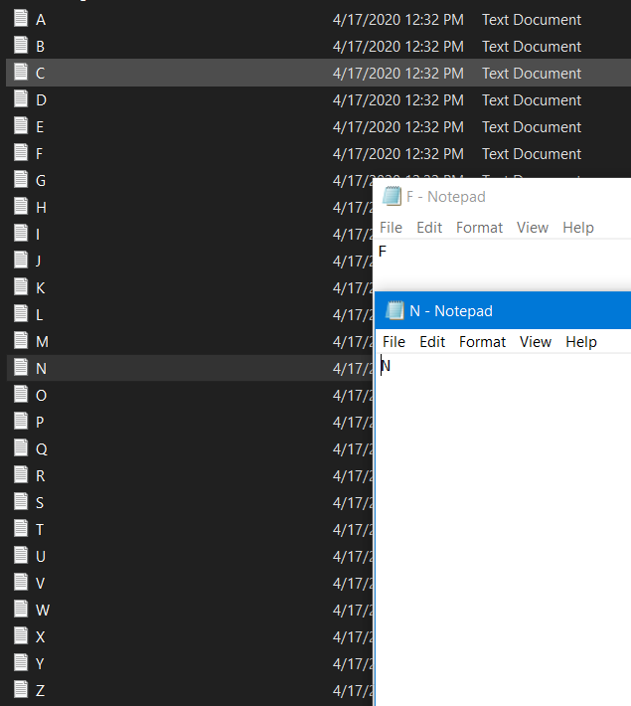

**6. Write a Python program to create a file where all letters of English alphabet are listed by specified number of letters on each line.**

Sol.

import string

def letters_file_line(n):

with open("words1.txt", "w") as f:

alphabet = string.ascii_uppercase

letters = [alphabet[i:i + n] + "\n" for i in range(0, len(alphabet), n)]

f.writelines(letters)

num=int(input("Enter the number: "))

letters_file_line(num)



